1. Justification for selecting a specific architecture pattern for Case study project

**Implemented architectures:**

1. Object-orientated
2. 3 tier
3. Web Architecture
4. MVC (Model View Controller) as it is a current standard, utilizing the DRY (Do not repeat yourself) principle in a manner to structure code using the MVC pattern with a technology using MVC principles like Django as opposed to utilizing a technology like PHP with a more procedural approach to write code with a top down/scripting approach i.e. consequently needing to write code and raw SQL for each HTML elements as needed to return or persist data to a database; both PHP and SQL can suffer from violating DRY. MVC model and Django are efficient given the specific use case and the scale of the Music School vs a top down procedural style as the project and development is easier (no need to configure XML) to manage and the product can be produced faster to meet deadlines (milestones).

1. Logical and Physical diagrams of the chosen architecture pattern for Case study project

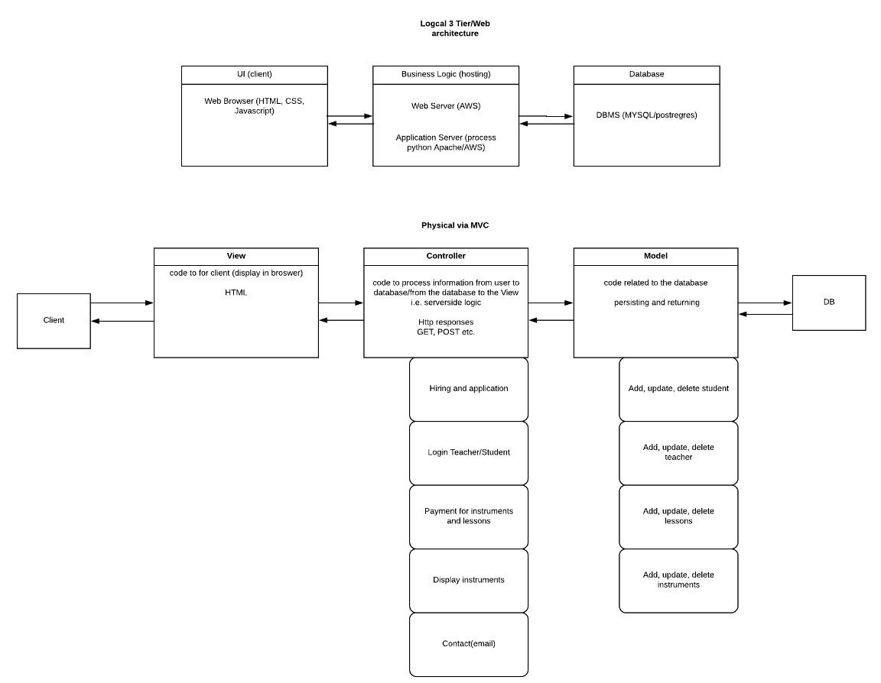

1. Component Diagram for Case study project

TODO:

1. Data Flow Diagram for Case study project

TODO: